Document # 1

Document # 2
Document # 3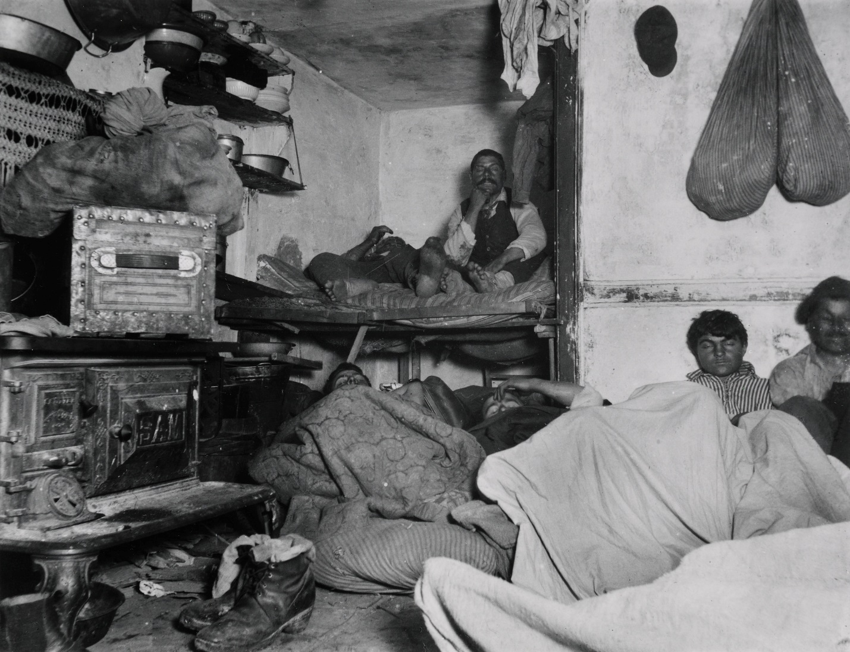
Jacob Riis “How the Other Half Lives” 1890

Document # 4
Source: Men Serving in American Government by Net Worth, 1765–1790
Adapted from Jackson T. Main, "Government by the People: The American Revolution and the Democratization of the Legislatures," William and Mary Quarterly, 3rd ser., vol. 23 (1966). Reprinted by permission.
[INSERT F03.01: Men Serving in American Government by Net Worth, 1765-1790 from Henretta 7e 031238789X]

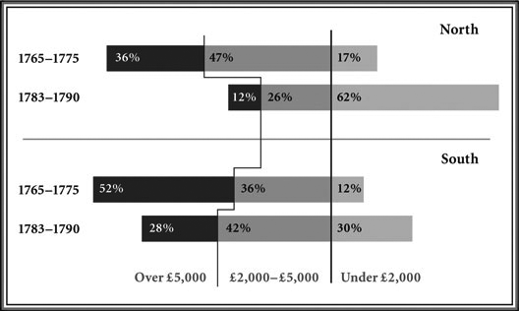

Document # 5
Source: Josiah Strong, The Dangers of Cities, 1886
From Our Country: Its Possible Future and Its Present Crisis (Baker & Taylor Co. for the American Home Missionary Society, 1891), 179, 180–182, 183, 190–193.

The city has become a serious menace to our civilization, because in it, excepting Mormonism, each of the dangers we have discussed is enhanced, and all are focalized. It has a peculiar attraction for the immigrant. Our fifty principal cities in 1880 contained 39.3 per cent of our entire German population, and 45.8 percent of the Irish. Our ten larger cities at that time contained only nine per cent of the entire population, but 23 per cent of the foreign.…Because our cities are so largely foreign; Romanism finds in them its chief strength. For the same reason the saloon, together with the intemperance and the liquor power which it represents, is multiplied in the city.…Not only does the proportion of the poor increase with the growth of the city, but their condition becomes more wretched.…Socialism centers in the city, and the materials of its growth are multiplied with the growth of the city. Here is heaped the social dynamite…

Document # 6

Document # 7

